Soduko Solver Project



Bs (Software Engineering)
Session (2024-2028)
Semester 3rd

Submitted By:
Izza numan 24251252028

Submitted to:

Miss Tuba Yonus

Project Title :
Soduko Solver Project

Source Code (Python):

# ==========================================================
# ADVANCED SUDOKU SOLVER
# ==========================================================
# This project demonstrates the implementation of:
# 1. Linked List -> Tracking empty Sudoku cells
# 2. Binary Search Tree (BST) -> Storing solved values
# 3. Hash Tables -> Fast constraint checking
# 4. File Handling -> Saving and loading Sudoku
# Algorithm Used:
# Backtracking Algorithm
# ==========================================================

# ----------------------------------------------------------
# SECTION 1: LINKED LIST IMPLEMENTATION
# ----------------------------------------------------------
class Node:
"""
Node class represents a single empty cell position
Each node stores:
- Row index
- Column index
- Reference to next node
"""
def __init__(self, row, col):
self.row = row
self.col = col
self.next = None
class LinkedList:
"""
Linked List stores all empty positions in the Sudoku grid.
It helps in systematic traversal of empty cells.
"""
def __init__(self):
self.head = None
def add(self, row, col):
new_node = Node(row, col)
new_node.next = self.head
self.head = new_node
def is_empty(self):
return self.head is None
def get_cells(self):
cells = []
current = self.head
while current:
cells.append((current.row, current.col))
current = current.next
return cells
def count(self):
count = 0
temp = self.head
while temp:
count += 1
temp = temp.next
return count
def display(self):
temp = self.head
while temp:
print(f"({temp.row}, {temp.col}) -> ", end="")
temp = temp.next
print("NULL")
# ----------------------------------------------------------
# SECTION 2: BINARY SEARCH TREE (BST)
# ----------------------------------------------------------
class BSTNode:
"""
BST Node stores a solved Sudoku number.
"""
def __init__(self, key):
self.key = key
self.left = None
self.right = None
class BST:
"""
Binary Search Tree stores solved numbers
and displays them in sorted order using inorder traversal.
"""
def __init__(self):
self.root = None
def insert(self, key):
self.root = self._insert(self.root, key)
def _insert(self, root, key):
if root is None:
return BSTNode(key)
if key < root.key:
root.left = self._insert(root.left, key)
elif key > root.key:
root.right = self._insert(root.right, key)
return root
def inorder(self):
result = []
self._inorder(self.root, result)
return result
def _inorder(self, root, result):
if root:
self._inorder(root.left, result)
result.append(root.key)
self._inorder(root.right, result)
def is_empty(self):
return self.root is None
# ----------------------------------------------------------
# SECTION 3: HASH TABLES (DICTIONARIES)
# ----------------------------------------------------------
rows = {}
cols = {}
boxes = {}
def initialize_hash_tables():
for i in range(9):
rows[i] = set()
cols[i] = set()
boxes[i] = set()
def calculate_box_index(row, col):
return (row // 3) * 3 + (col // 3)
def add_number(row, col, num):
rows[row].add(num)
cols[col].add(num)
boxes[calculate_box_index(row, col)].add(num)
def remove_number(row, col, num):
rows[row].remove(num)
cols[col].remove(num)
boxes[calculate_box_index(row, col)].remove(num)
def is_valid(row, col, num):
box = calculate_box_index(row, col)
return (
num not in rows[row] and
num not in cols[col] and
num not in boxes[box]
)
# ----------------------------------------------------------
# SECTION 4: FILE HANDLING
# ----------------------------------------------------------

def save_sudoku(grid):
try:
with open("sudoku.txt", "w") as file:
for row in grid:
file.write(" ".join(map(str, row)) + "\n")
print("Sudoku saved to file successfully.")
except IOError as e:
print(f"Error saving Sudoku: {e}")
def load_sudoku():
try:
grid = []
with open("sudoku.txt", "r") as file:
for line in file:
grid.append(list(map(int, line.split())))
print("Sudoku loaded from file successfully.")
return grid
except IOError as e:
print(f"Error loading Sudoku: {e}")
return None
except ValueError as e:
print(f"Invalid file format: {e}")
return None
# ----------------------------------------------------------
# SECTION 5: DISPLAY UTILITIES
# ----------------------------------------------------------
def print_separator():

print("=" * 40)
def display_grid(grid):
print("\nCurrent Sudoku Grid:")
for i, row in enumerate(grid):
if i % 3 == 0 and i != 0:
print("-" * 25)
row_str = ""
for j, cell in enumerate(row):
if j % 3 == 0 and j != 0:
row_str += "| "
row_str += str(cell) + " "
print(row_str)
# ----------------------------------------------------------
# SECTION 6: BACKTRACKING SOLVER
# ----------------------------------------------------------
def solve(grid, empty_cells, index):
if index == len(empty_cells):
return True
row, col = empty_cells[index]
for num in range(1, 10):
if is_valid(row, col, num):
grid[row][col] = num
add_number(row, col, num)
if solve(grid, empty_cells, index + 1):
bst.insert(num)
return True
grid[row][col] = 0
remove_number(row, col, num)
return False
# ----------------------------------------------------------
# SECTION 7: SUDOKU INITIALIZATION
# ----------------------------------------------------------
def get_default_sudoku():
return [
[5, 3, 0, 0, 7, 0, 0, 0, 0],
[6, 0, 0, 1, 9, 5, 0, 0, 0],
[0, 9, 8, 0, 0, 0, 0, 6, 0],
[8, 0, 0, 0, 6, 0, 0, 0, 3],
[4, 0, 0, 8, 0, 3, 0, 0, 1],
[7, 0, 0, 0, 2, 0, 0, 0, 6],
[0, 6, 0, 0, 0, 0, 2, 8, 0],
[0, 0, 0, 4, 1, 9, 0, 0, 5],
[0, 0, 0, 0, 8, 0, 0, 7, 9]
]
def setup_structures(grid, ll):
for i in range(9):
for j in range(9):
if grid[i][j] == 0:
ll.add(i, j)
else:
add_number(i, j, grid[i][j])
# ----------------------------------------------------------
# SECTION 8: MAIN PROGRAM (MENU DRIVEN)
# ----------------------------------------------------------
bst = BST()
def reinitialize_all(sudoku, ll):
"""Reset all data structures for a new puzzle."""
global bst
initialize_hash_tables()
bst = BST()
ll = LinkedList()
setup_structures(sudoku, ll)
return ll
def main():
global bst
initialize_hash_tables()
sudoku = get_default_sudoku()
ll = LinkedList()
setup_structures(sudoku, ll)
while True:
print_separator()
print("1. Display Sudoku")
print("2. Solve Sudoku")
print("3. Save Sudoku")
print("4. Load Sudoku")
print("5. Display BST (Inorder Traversal)")
print("6. Exit")
print_separator()
choice = input("Enter your choice: ")
if choice == '1':
display_grid(sudoku)
elif choice == '2':
empty_cells = ll.get_cells()
if solve(sudoku, empty_cells, 0):
print("Sudoku Solved Successfully!")
display_grid(sudoku)
else:
print("No solution exists.")
elif choice == '3':
save_sudoku(sudoku)
elif choice == '4':
loaded_sudoku = load_sudoku()
if loaded_sudoku:
sudoku[:] = loaded_sudoku
ll = reinitialize_all(sudoku, ll)
else:
print("Failed to load. Using current Sudoku.")
elif choice == '5':
print("BST Inorder Traversal:", bst.inorder())
elif choice == '6':
print("Program Terminated.")
break
else:
print("Invalid choice! Please try again.")
# ----------------------------------------------------------
# PROGRAM EXECUTION
# ----------------------------------------------------------
main()

Report:
Topic: Soduko Solver

1. Problem Statement
Solving Sudoku puzzles efficiently is a common problem in programming and AI applications. Users often face challenges in solving Sudoku manually or checking the validity of inputs while keeping track of the board state. A simple 2D array is often insufficient for advanced operations like searching for empty cells, validating numbers efficiently, and storing multiple solved states for history or comparison.The goal of this project is to design and implement a Sudoku Solver System that allows users to:
- Add / Input Puzzle: Input a Sudoku puzzle from a CSV file or manually with attributes (Row, Column, Number).
B. Solve / Compute: Solve the puzzle using a backtracking algorithm.
C. Validate: Check if a number can be placed at a specific position.
D. Display: Show the board in multiple formats:
- Sequential entry order (as input)
- Solved board
- Persist: Save the board state using file handling to ensure the puzzle can be loaded and resumed later.To achieve robust performance and demonstrate proficiency in algorithmic concepts, the system integrates three distinct data structures: Linked Lists, Binary Search Trees (BST), and Hash Tables.

2. Chosen Data Structures & Justification
To meet the requirement of using at least three major data structures, the system maintains the same puzzle data across three synchronized structures:
A. Hash Table (Fast Cell Lookup)
- Usage: Stores the positions of all filled numbers for quick validation.
- Justification: Hash Tables allow O(1) average lookup for checking if a number already exists in a row, column, or box. This speeds up validation during the solving process. Collisions are handled using chaining.
B. Binary Search Tree (BST) (Sorted Storage / History)
- Usage: Maintains a sorted order of moves based on the cell's unique ID (Row * 9 + Column).
- Justification: BST enables traversals to view the sequence of moves in a sorted manner, providing a clear and ordered history of the solving process. Inorder traversal provides the moves sorted by cell IDs.
C. Singly Linked List (Input / Entry Order)
- Usage: Stores the board as the user enters numbers sequentially.
- Justification: Linked Lists maintain insertion order, which allows users to see the puzzle exactly as they inputted it, providing a historical log and demonstrating dynamic memory allocation.

3. Implementation Details & Complexity Analysis
The system is implemented in Python using a class-based modular approach. The SudokuSolver class acts as a facade, coordinating operations across the LinkedList, BST, and HashTable classes to ensure consistency.

Complexity Analysis Table
Operation | Data Structure | Algorithm Used | Time Complexity (Average) | Time Complexity (Worst Case)
Insert Cell / Input | Linked List | Linear Insert | O(1) (tail) / O(n) | O(n)
Validate Number | Hash Table | Hashing + Chaining | O(1) | O(n) (collision)
Store Move / History | BST | Recursive Insert | O(log n) | O(n) (Skewed Tree)
Solve Puzzle | BST / Backtracking | Recursive Backtracking | O(9^m) (m = empty cells) | O(9^m)
Display Board | Linked List / BST | Traversal | O(n) | O(n)
File Handling (Save) | Linked List | CSV Write | O(n) | O(n)
File Handling (Load) | Linked List | CSV Read + Insert | O(n) | O(n)

File Handling
The project implements persistence using CSV files:
- Saving: save_board() method iterates through the master linked list of entries and writes row, column, number to sudoku_data.csv.
- Loading: load_board() reads the CSV line-by-line, creating objects and inserting them into the Linked List, BST, and Hash Table to restore the board state.

4. Features & Screenshots Description

1. Program Start (Menu Display)
At the start, the program displays the following menu:
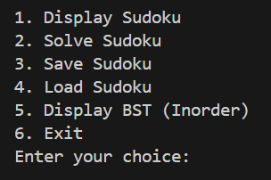

2. Display Sudoku (Option 1)
When the user selects Option 1, the program prints the current Sudoku grid.
Empty cells are displayed as 0.

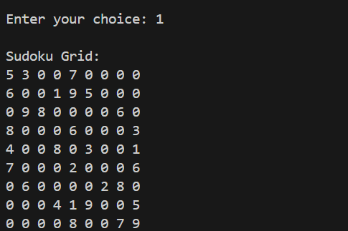

3. Solve Sudoku (Option 2) :
When Option 2 is selected, the program:
Uses the Backtracking algorithm ,Checks constraints using Hash Tables,Fills empty cells stored in the Linked List,Stores solved values in the Binary Search Tree,If a solution exists, the solved Sudoku is displayed.
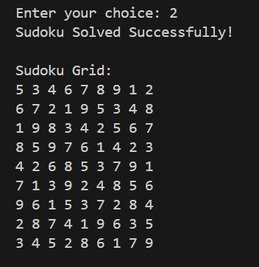

4. Save Sudoku (Option 3)
When Option 3 is selected, the current Sudoku grid is saved to a text file named sudoku.txt.
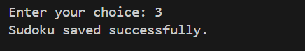

5. Load Sudoku (Option 4)
When Option 4 is selected, the program loads the Sudoku grid from the file and displays a confirmation message.


6. Display BST Inorder Traversal (Option 5)
When Option 5 is selected, the program displays the values stored in the Binary Search Tree using inorder traversal, which shows the numbers in sorted order.

7. Exit Program (Option 6)
When Option 6 is selected, the program terminates execution.
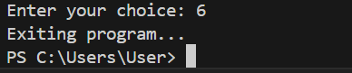

Conclusion:
The Sudoku Solver project not only serves as a practical implementation of algorithmic techniques but also provides an engaging platform for puzzle enthusiasts. By allowing users to actively contribute to the puzzle and giving them a choice in the level of difficulty, the solver offers a personalized and enjoyable experience, contributing to the broader landscape of Python-based algorithmic applications.

